Adding the spring simple form and hiding the employee access to student and vice versa

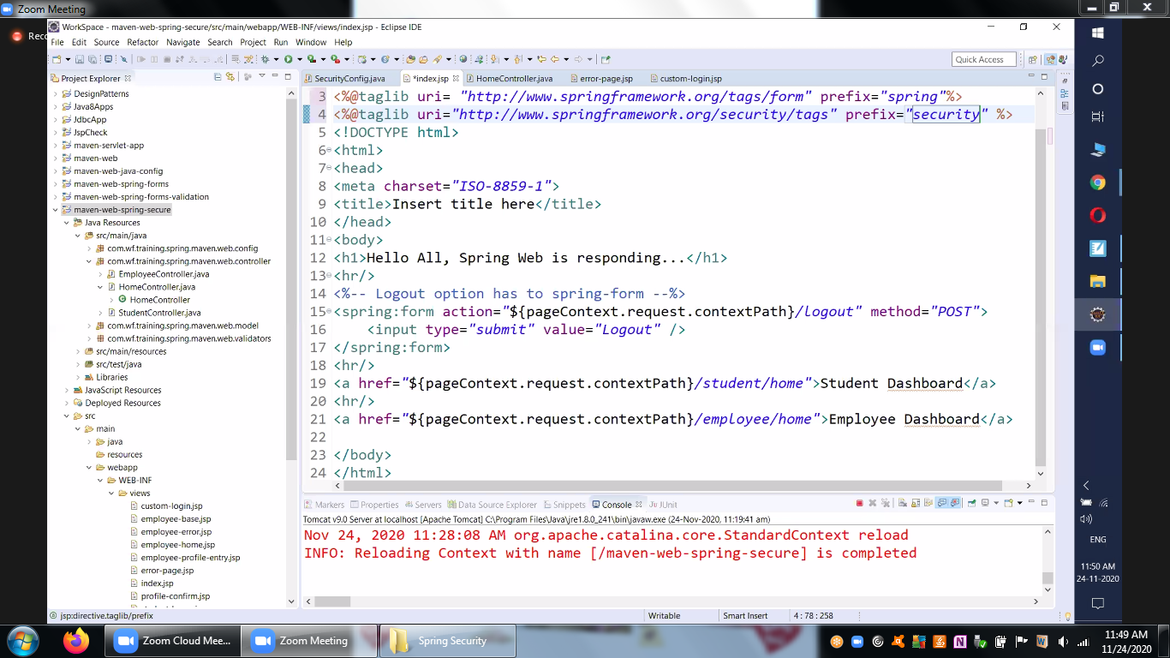

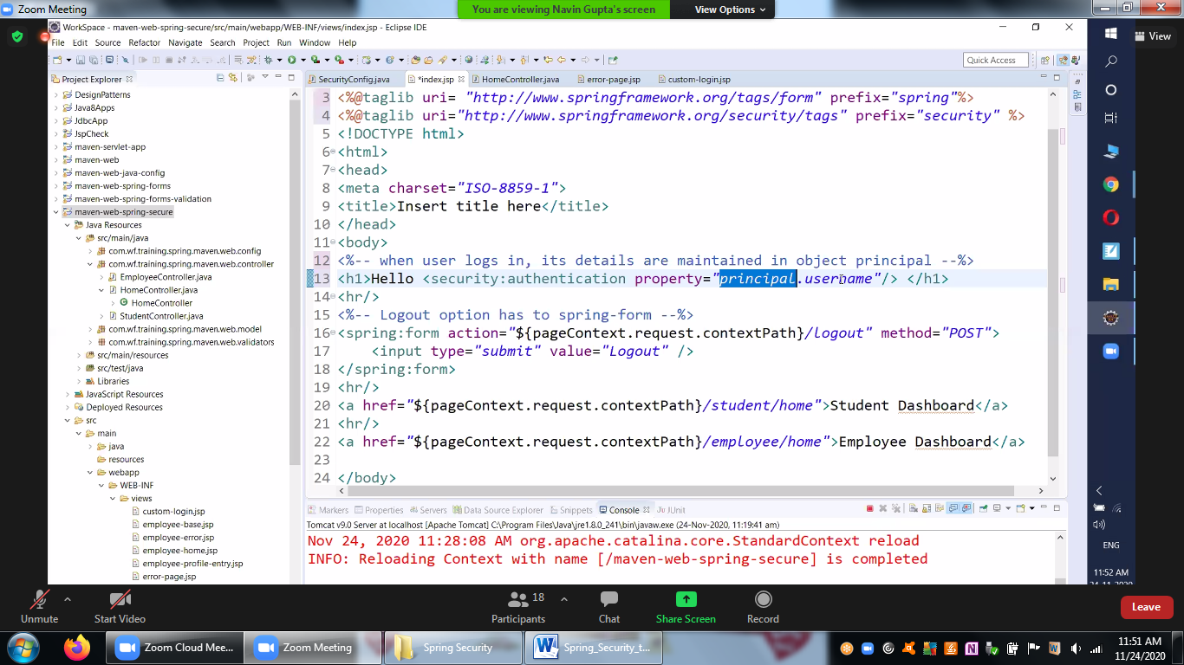

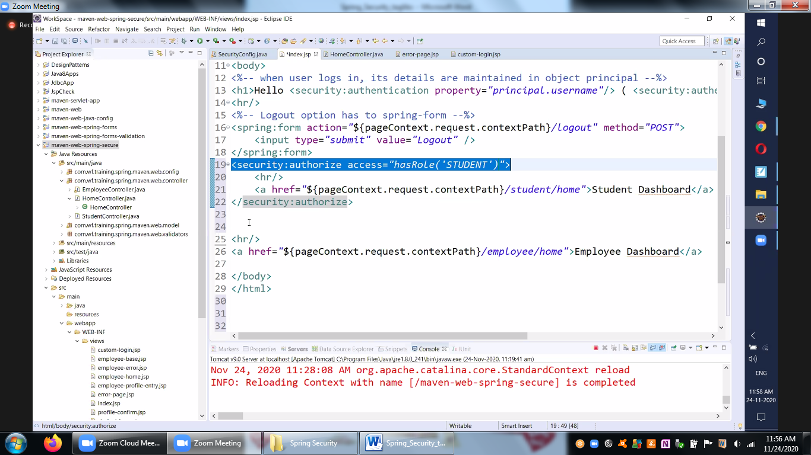

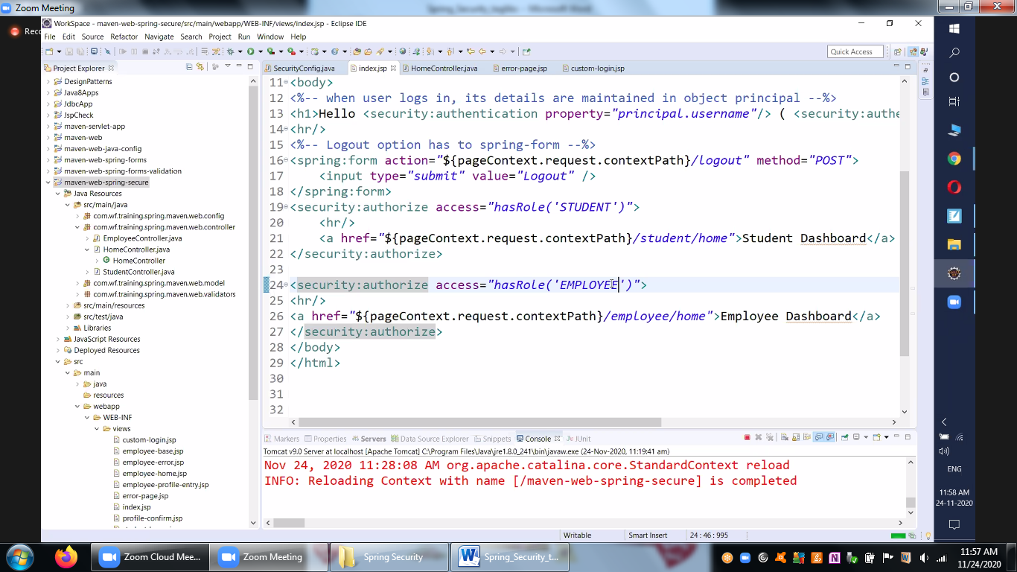

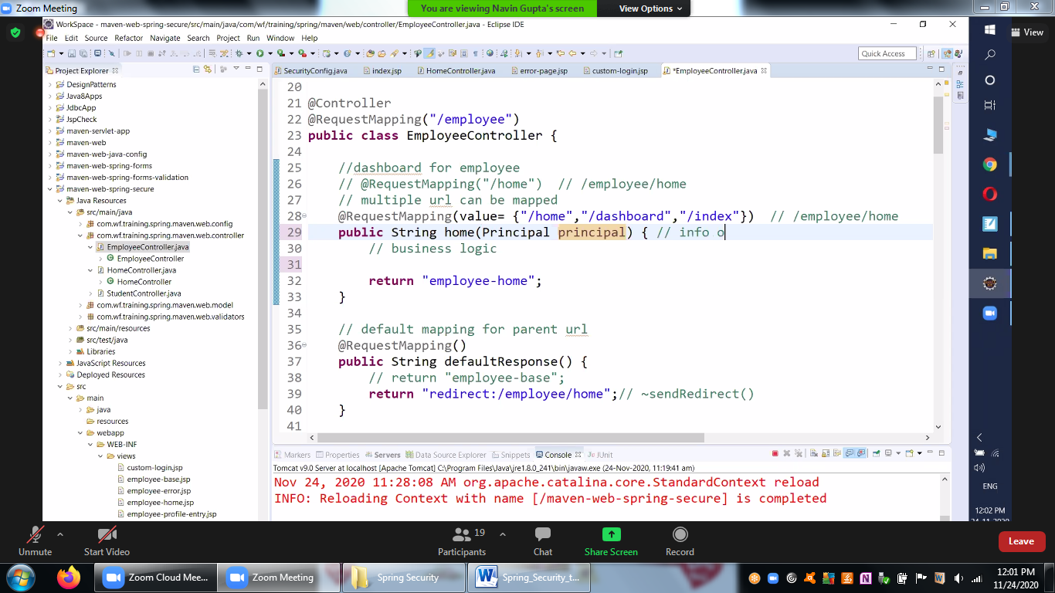

Invalid Credentials Scenario and User successful logout is below

We will take the JSTL tags to perform the same

Its good add prefix for taglib for identifying the taglibs

